7. Project Documentation
Project Name: Auto Ticket Classification Using Flow Designer
Team Leader:J. Pavithra
Members: M. Keerthika, M. Pradeepa, P. Sivaranjani

7.1 Project Report

1. Introduction
Auto Ticket Classification Using Flow Designer is a ServiceNow-based automation project designed to simplify the classification and assignment of incident tickets. The project uses Flow Designer to process tickets based on predefined conditions and route them to the appropriate assignment group.

2. Problem Statement
Manual ticket classification and assignment can require additional time and may lead to incorrect routing. An automated process can help reduce repetitive manual work and provide consistent ticket handling.

3. Objectives
- To automate ticket classification.
- To reduce manual ticket assignment.
- To process incident tickets using Flow Designer.
- To assign tickets to the appropriate assignment group.
- To improve ticket management efficiency.

4. Technologies Used
Technology / Tool | Purpose
ServiceNow | Project platform
Flow Designer | Workflow automation
GitHub | Project repository and submission
Microsoft Word / PDF | Documentation

5. System Design
System Architecture of Auto Ticket Classification
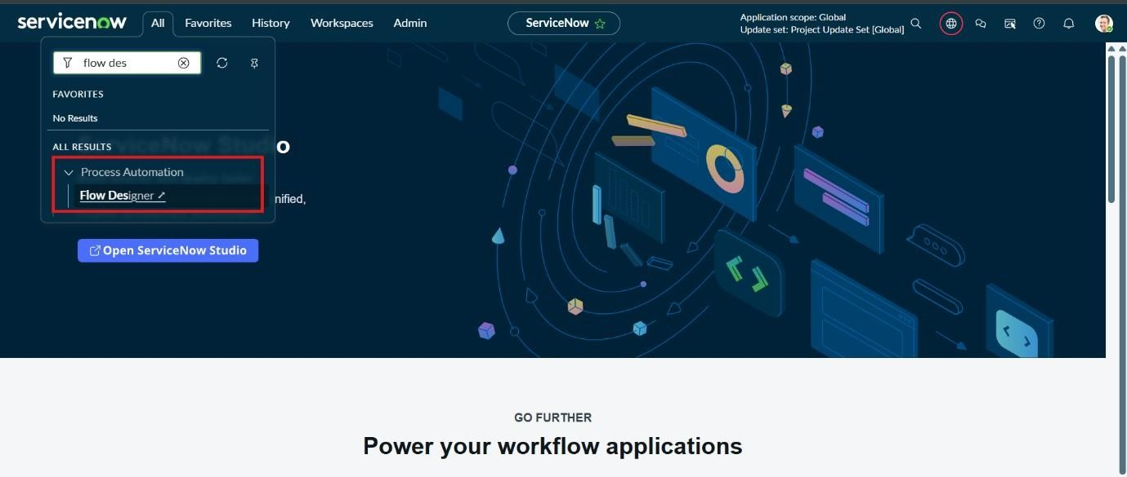

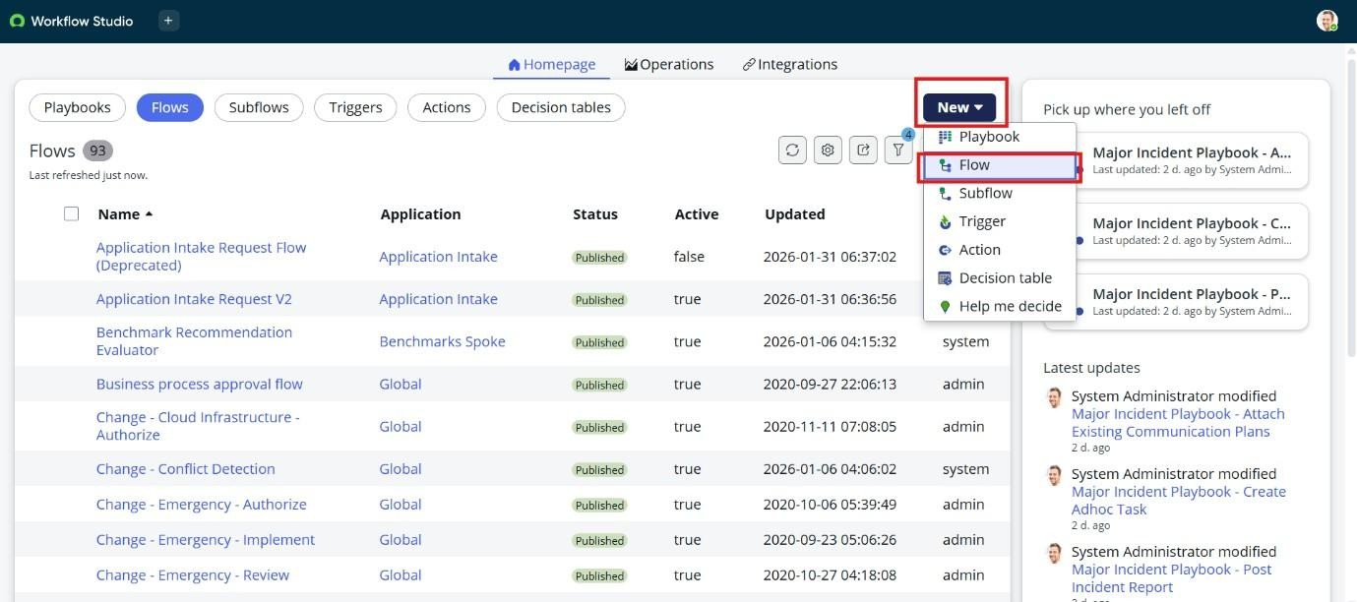
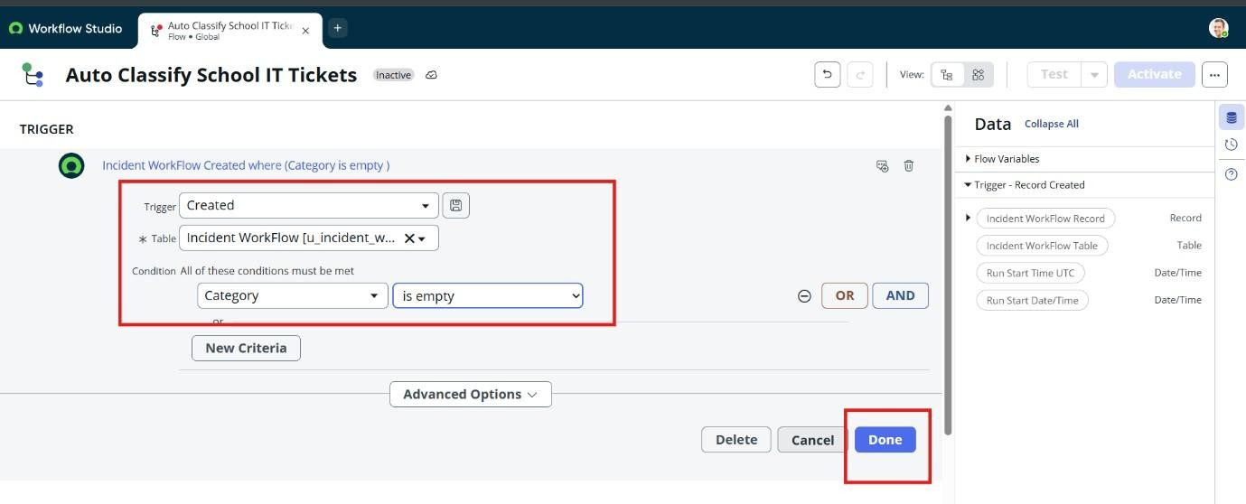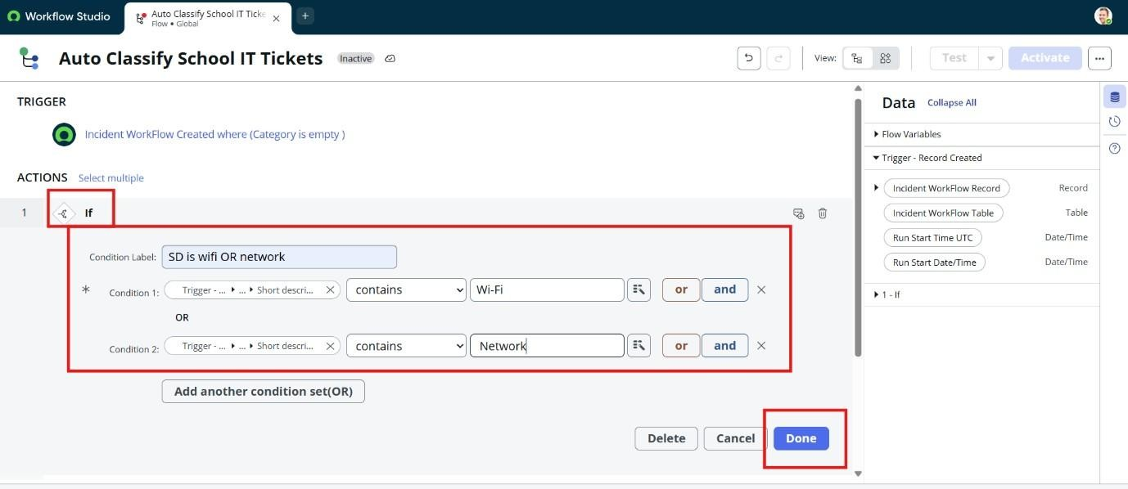

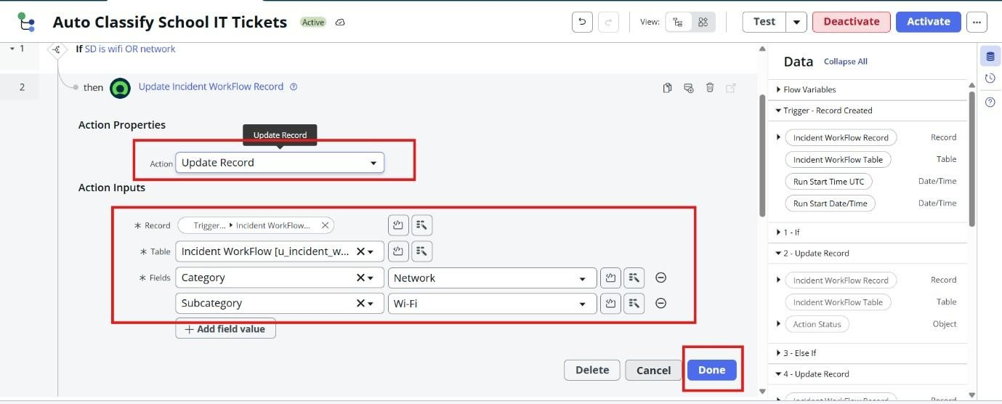

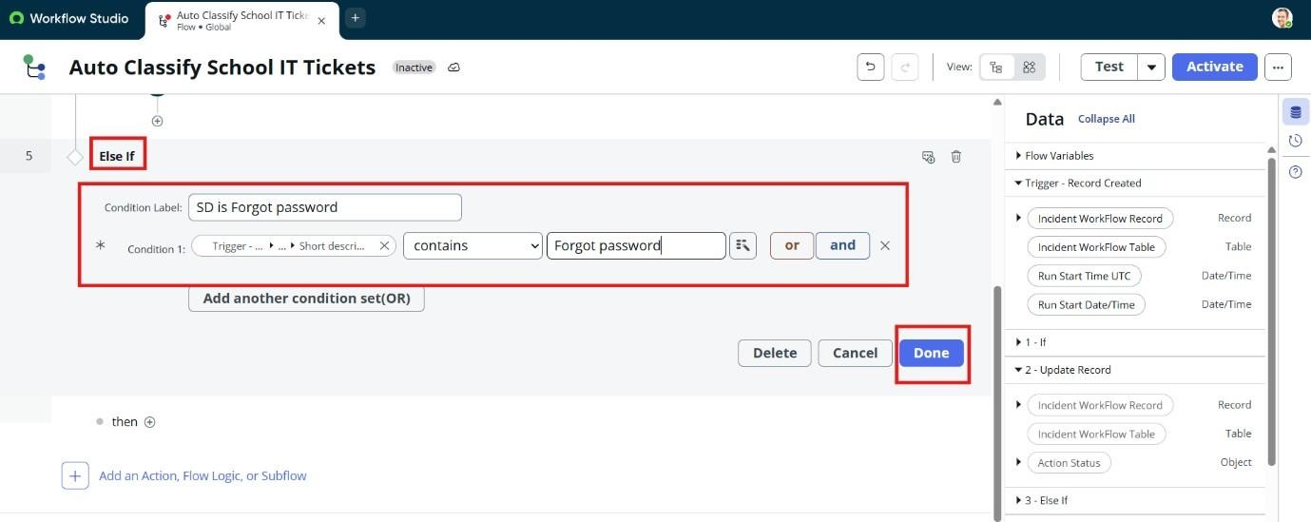

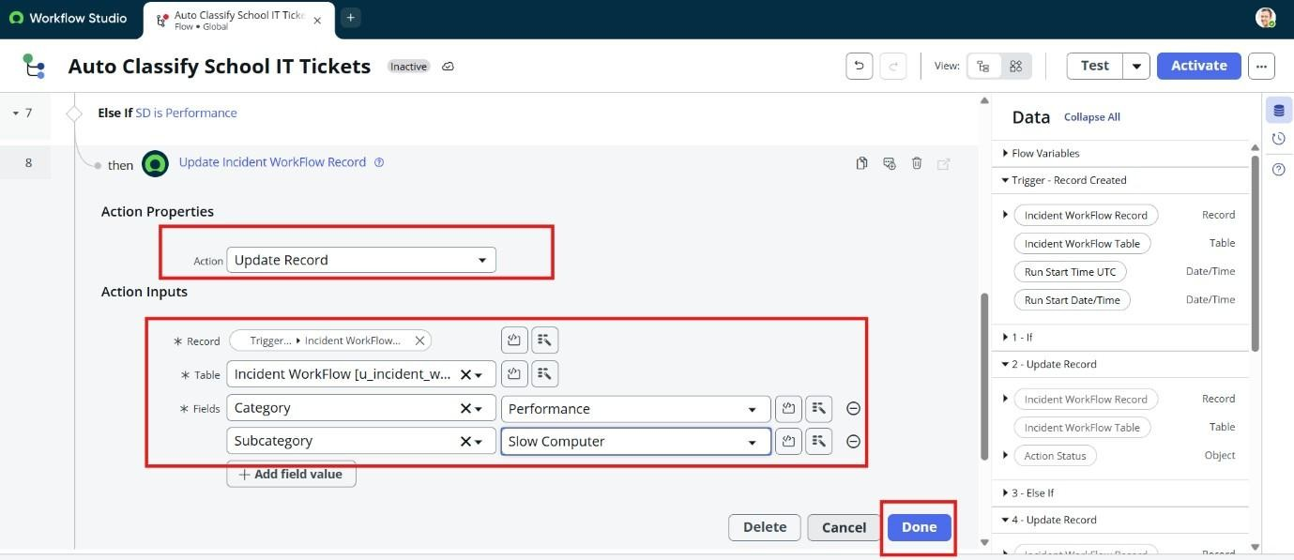

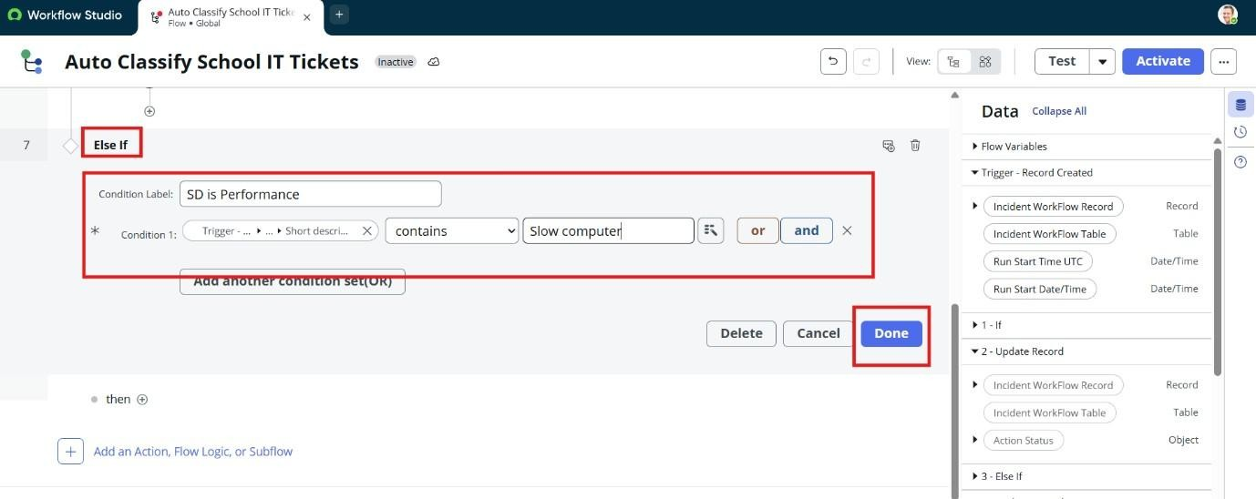

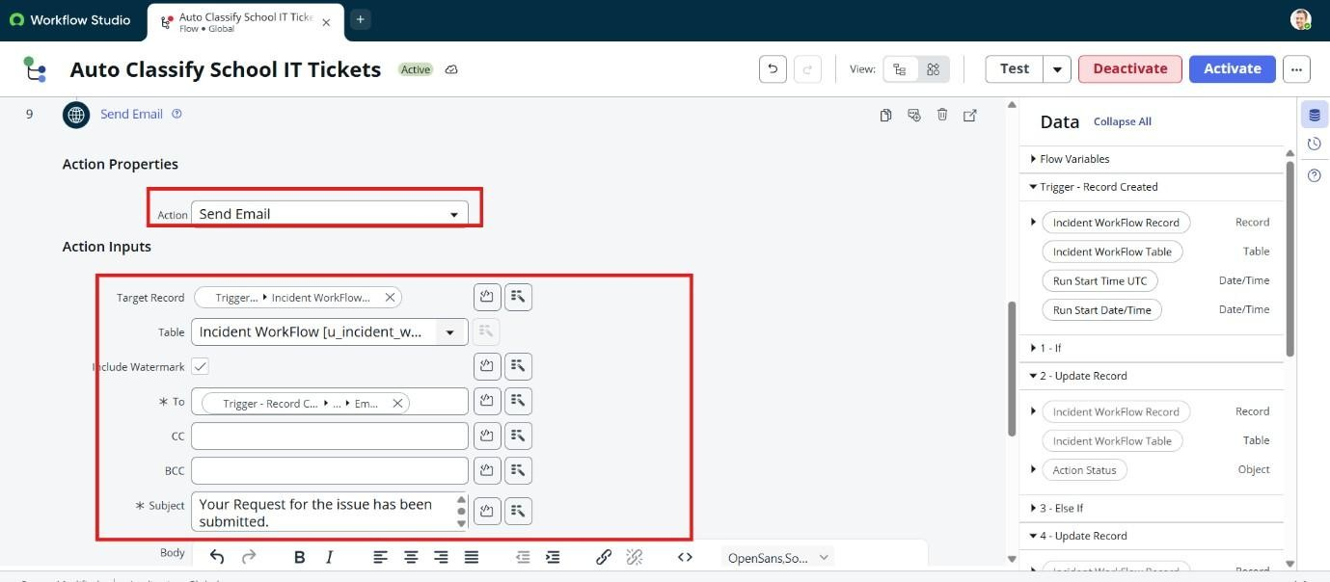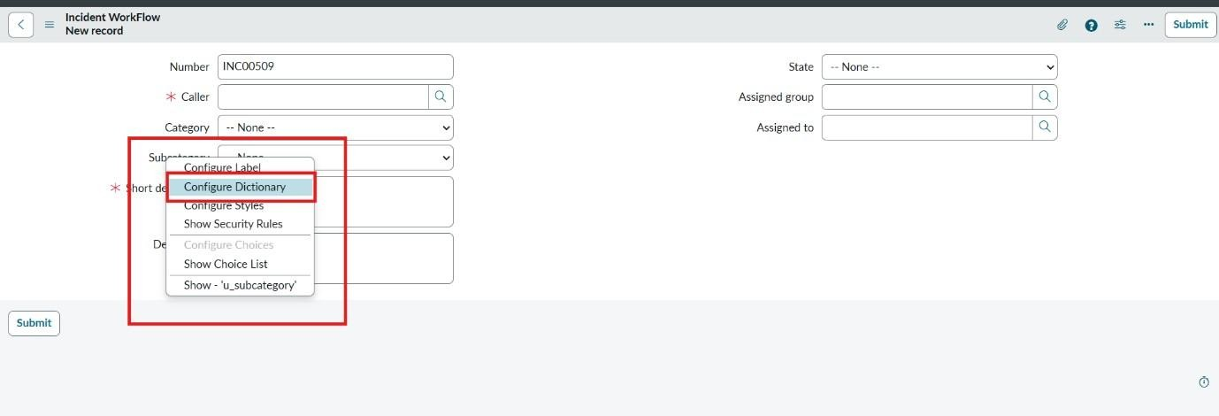

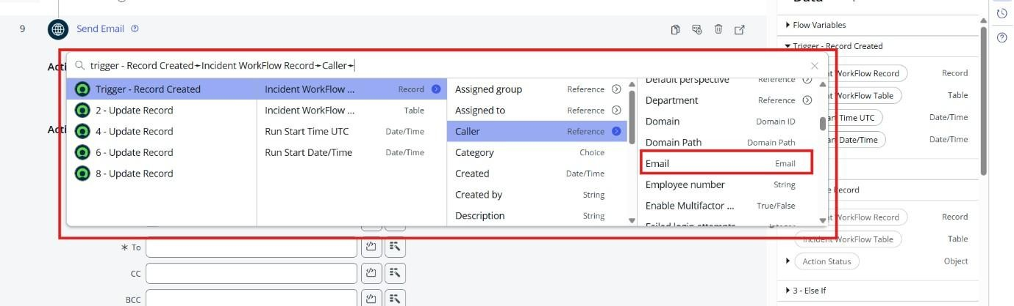

6. Implementation
- Flow creation
- Trigger configuration
- Conditions
- Assignment Group
- Completed Flow
- Incident creation

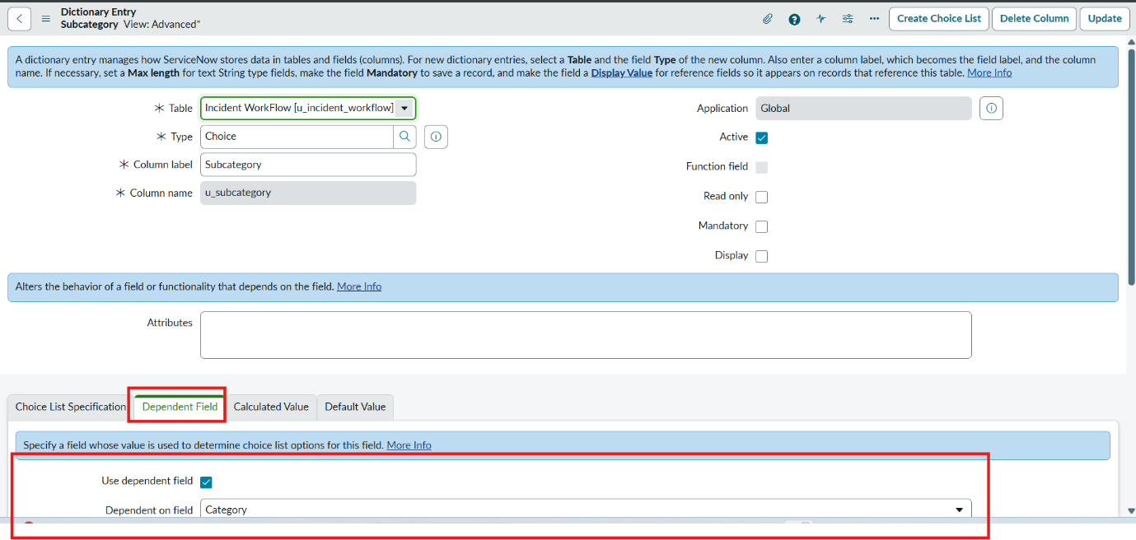

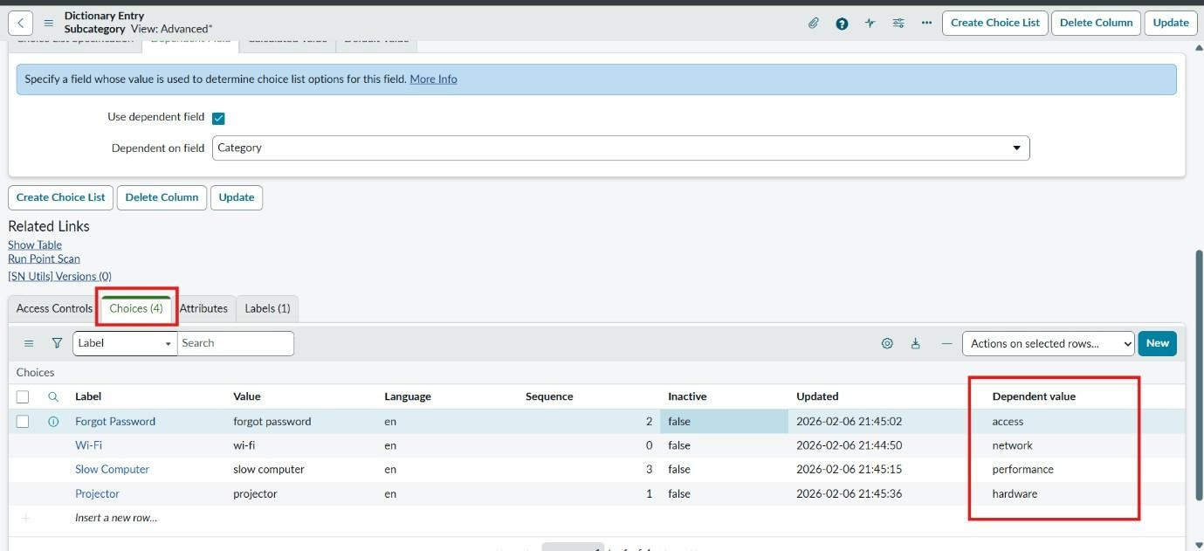

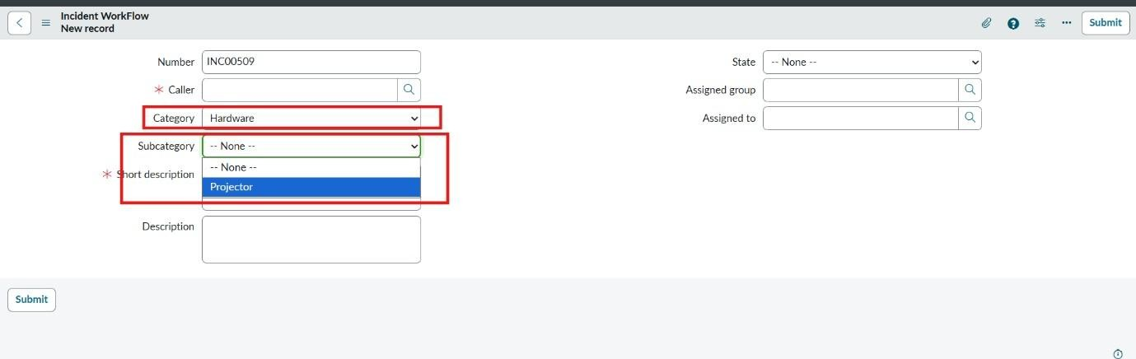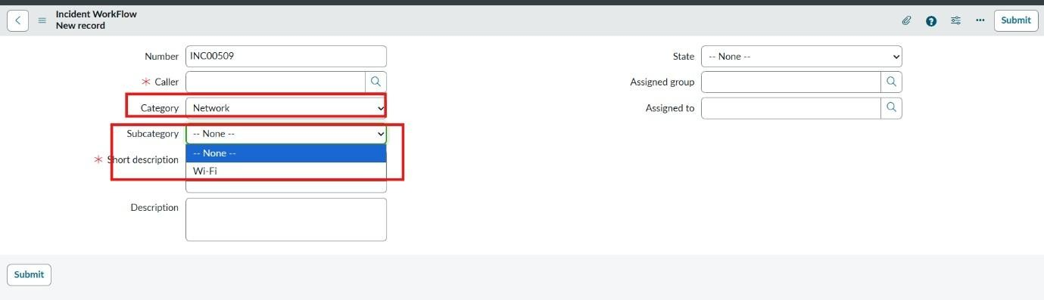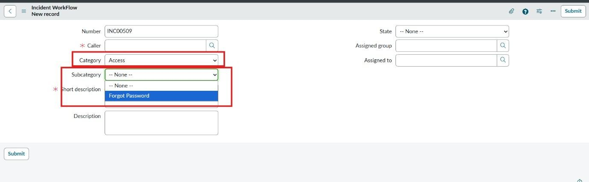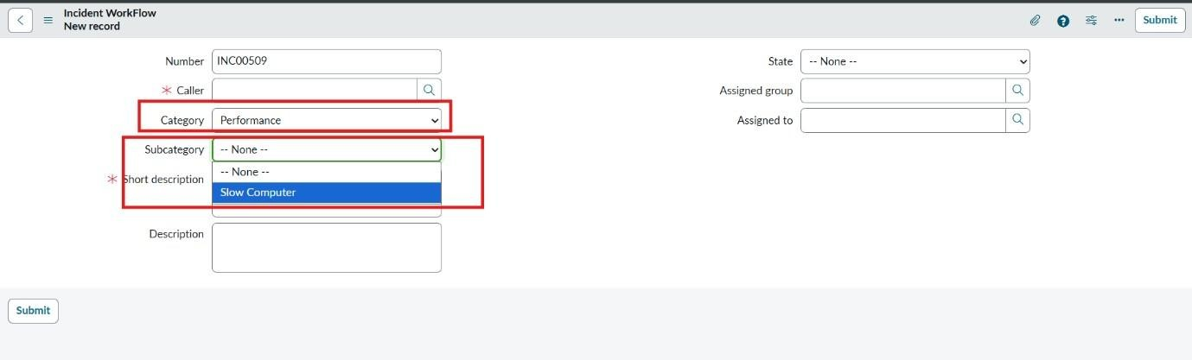

7. Testing
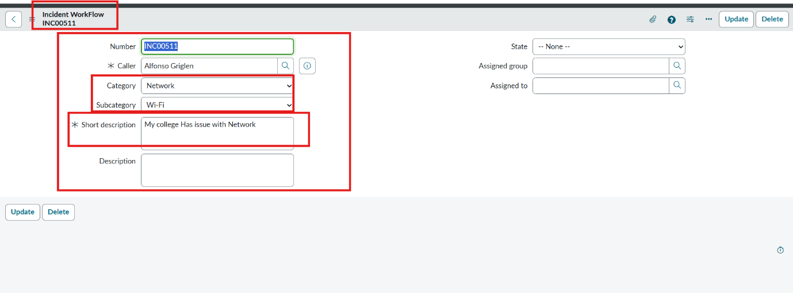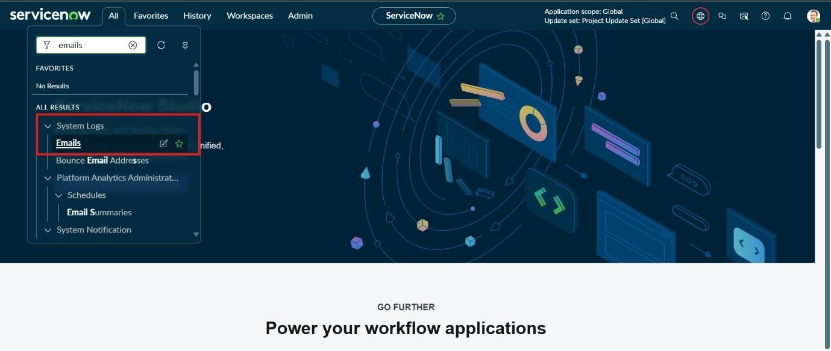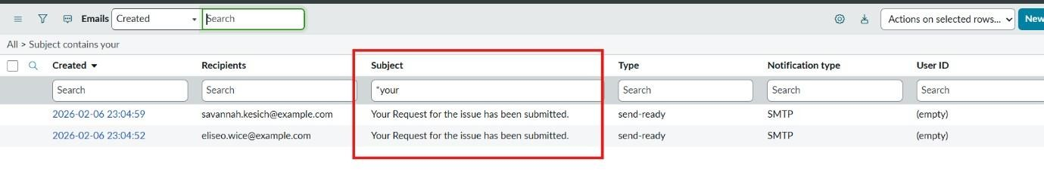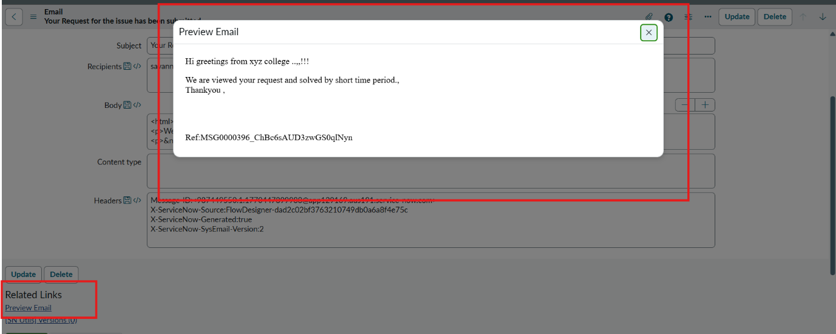
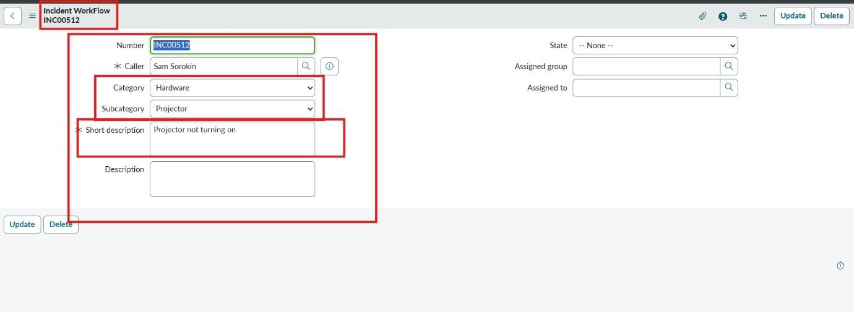

8. Result
The developed Flow Designer workflow was tested using incident tickets. The configured flow processes the ticket based on the defined conditions and performs the required classification and assignment actions.

9. Conclusion
The project demonstrates how ServiceNow Flow Designer can be used to automate ticket classification and assignment. The automated workflow helps reduce repetitive manual activities and provides a structured approach to ticket management.

10. Future Enhancement
- More ticket categories can be added.
- More assignment rules can be configured.
- Additional automation actions can be included.
- Reporting and monitoring features can be enhanced.

